**SENG 310 Human Computer Interaction Midterm**

**Instructor: Dr. Sowmya Somanath**

Name (as it appears on CourseSpaces): ___Zheng Yin______________________________________

UVic ID number: __V00915261_______________________________

**Exam Details:**

* **Made available** – June 25
* **Due** – June 28, before 11:59pm Victoria Time
* **Test Duration:** You will have 4 days to complete the test
* This is an open book test
* Answer the questions in the document and when complete, you must save the file as a **PDF document** and use the following naming convention: midterm_<yourname>. **Upload the completed file to CourseSpaces**
* The answers to all the below questions included **must not exceed 10 pages in total**. The formatting of this document must not be altered. Use Calibri font and size 10.
* **Instructor email:** [sowmyasomanath@uvic.ca](mailto:sowmyasomanath@uvic.ca)
* **In the case of CourseSpaces issues, email:** [coursespaces@uvic.ca](mailto:coursespaces@uvic.ca)
* **Note:** No matter how scrupulous I have been there indeed may be typos or some clarification questions you might have. However, this is an exam, and I won't be able to make any changes on the fly once the exam period has started. So when in doubt, use your best judgment and go ahead and answer the questions.  If there are any unintentional ambiguities, just articulate them and if you provide sound reasoning, I will take that into account when grading. Do know however that some open-endedness is intentional as the point of the exam is for you to think and reason.

**Academic Integrity Pledge:**

Students must abide by [UVic academic regulations](https://web.uvic.ca/calendar2020-01/undergrad/info/regulations/academic-integrity.html) and observe standards of ‘scholarly integrity,’ (no plagiarism or cheating). Therefore, this online exam must be taken individually and not with a friend, classmate, or group. You are also prohibited from sharing any information about the exam with others. I __Zheng Yin___ (type in name) affirm that I will not give or receive any aid on this exam and that all work will be my own.

**Grade:**

This exam counts towards 20% of your final grade for this course.

|  |  |  |
| --- | --- | --- |
| **Question** | **Marks** | **Marks Received** |
| 1 | 5 |  |
| 2 | 5 |  |
| 3 | 10 |  |
| 4 | 10 |  |
| 5a | 5 |  |
| 5b | 5 |  |
| 5c | 10 |  |

**Total (out of 50):**

**Question 1:**

Explain **any five** of Don Norman’s Interaction Principles and provide examples for each principle from your everyday experiences. [5 marks]

Feedback: Interface should give the users some responses when they interact with the interface, like visual, tactile, audio and more. For example, when iPhone use touch home button instead physical home button, Apple add a vibration motor to simulate tactile of press button, so the users can know they press the home button even the button do not move.

Mapping: mapping is the relationship between controls and actions. A good example is the timeline of the video player, users can drag pointer to point the time user want to play, and timeline can show the video already played and the time left.

Affordance: affordance is the relationship between what something looks like and how it is used. For example, the car door handles are easy to use when people saw it, for it looks like something that can only open in one way. People can open car door by just pull the handles.

Constraints: Constraints set some limitations for how people interact with technology. The USB type-A port is an example of the constraints, for it can only be insert in one direction which can avoid people connect cable wrong direction that cause disconnect

Signifier: signifier is a communication mechanism (sound, mark or other perceivable indicator) that communicates appropriate behavior to the person. For example, if people see a right pointing triangle, they will think it is a play button to play music or video.

**This is NOT a question page but instructions for the following questions.**

**For the following questions, select a sub-part of the interface that was assigned to you (via the “Midterm Interface” Quiz on CourseSpaces) and use that to answer the questions.**

**Examples of sub-parts:**

Sub-part of an interface can consist of one of the below or a combination of the below examples.

1. A subpart for an entire system or interface can be a few specific screens on an app or webpages for websites
2. It can also consist of interaction sequences that enable people to complete 1-2 tasks
3. Sub-part can also consist of one specific and important feature of the interface

**When selecting the sub-part, I suggest you think about the following:**

1. Does your choice provide you with enough material to study and evaluate? That is, is it meaningful enough?

2. Can you use this sub-part for the exam questions without spending too much time and running out of space? (see the exam submission page limit requirements). That is, is your choice of sub-part manageable?

**Question 2:**

Describe the interface sub-part you are focusing on in details and include screenshot(s) as figures. Provide a rationale for why you selected the particular sub-part. [5 marks]

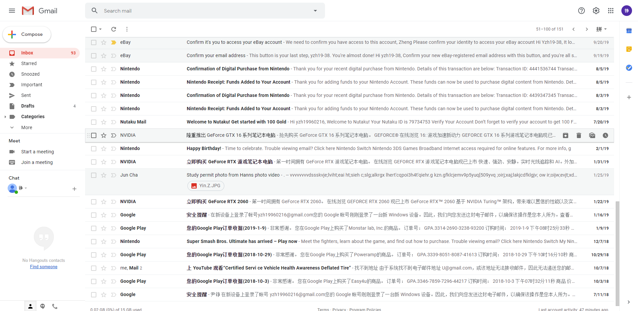

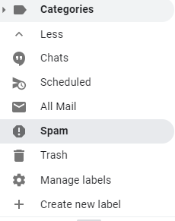

This is the main page of the Gmail, which include the category on the left, search on the top and email list on the remain part of the interface.

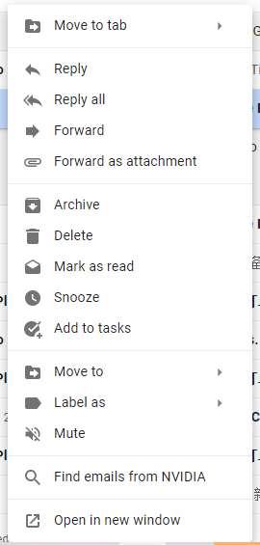

This is the right click menu of one email, include most function.

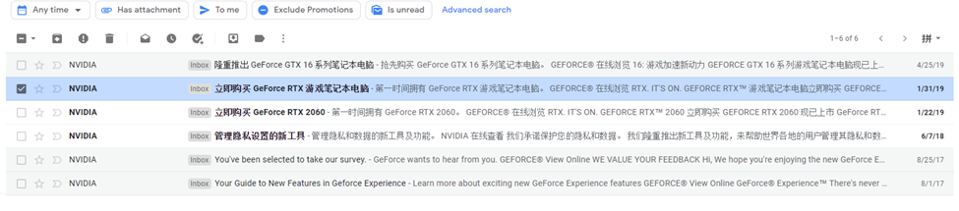

This is the email from one source which is NVidia.

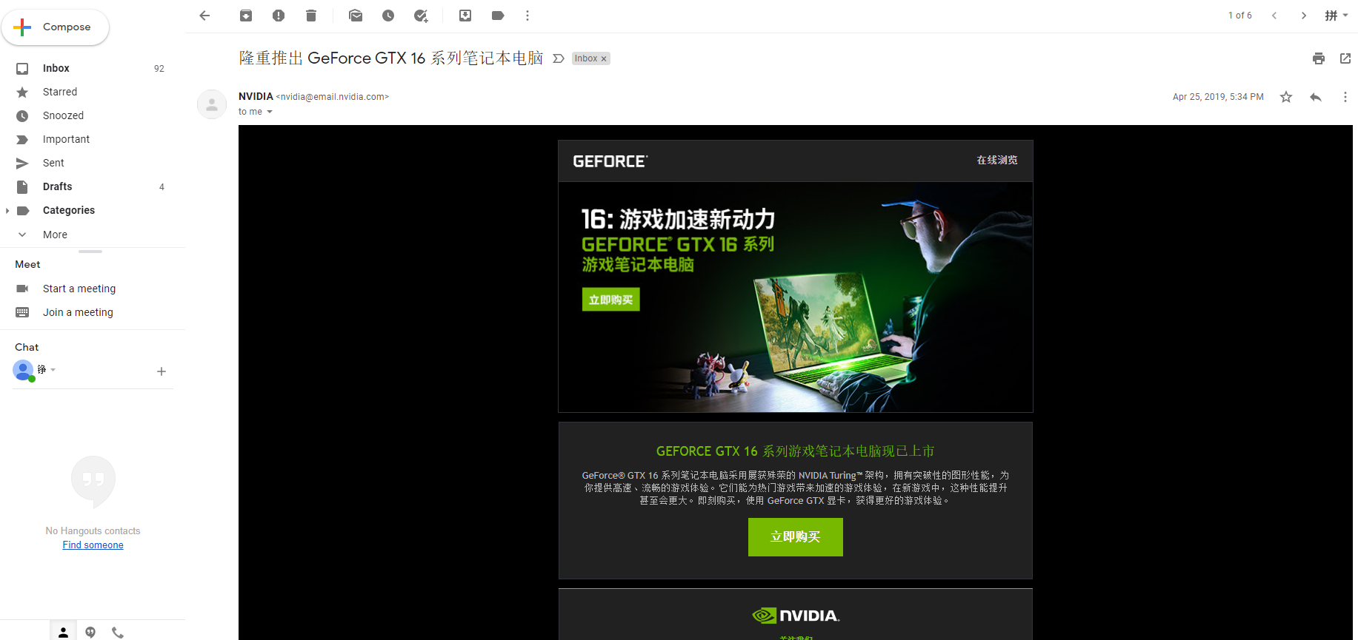

This is the individual mail interface which include the source information on the top.

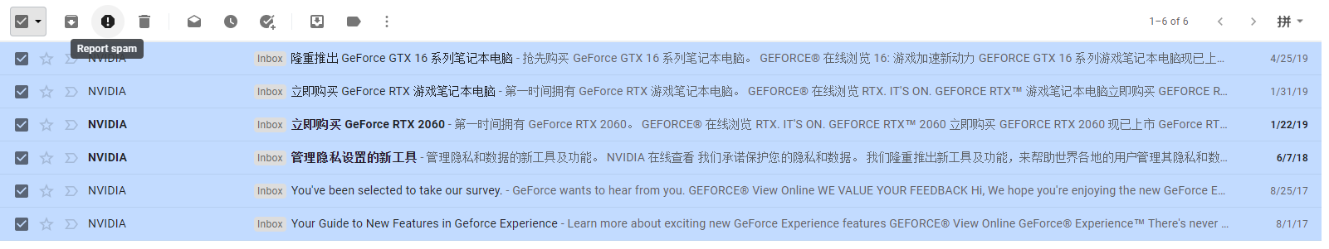

These four interfaces are the process of using sender of one email to find out all the email from this sender, then user can find the email he wants from that sender or delete them all. Due to COVID-19, email became an important way to connect each other. With the growing of email number, it is harder and harder to find out the email people want.

**Question 3:**

Provide a heuristic evaluation for that particular interface sub-part assuming that you are the end-user. The evaluation must clearly explain what the issue is and why you think that is an issue. You can add screenshot(s) as figure(s) if that is necessary for the explanation. Highlight **any 5** heuristics that the interface fails to meet. [10 marks]

Visibility of system status:

If user delete an email, it moves to trash box by Gmail. There is no sign on trash box that there is an email added to trash box.

Consistency and standards:



In the trash box is ordered by the time user receive emails, which the trash can in computer is ordered by the time trash move in. If an important email from long time ago is delete mistakenly now, user need to view several pages to find it in the trash box.

Error prevention:



In the trash box, if user press deletes forever for trash mails, there is no alert or double check.

Recognition rather than recall:

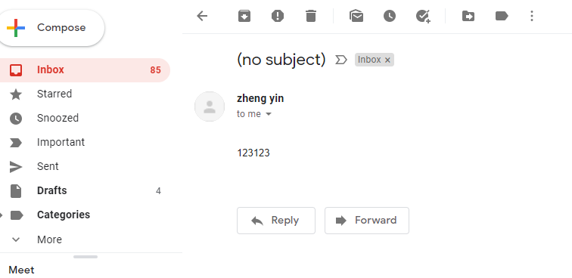

When user go into an individual email page, they can not see the list of the emails. Users had to remember which email they just read to avoid the same email be checked twice.

Flexibility and efficiency of use:

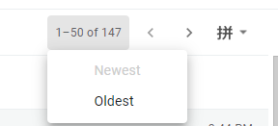

The mail can only be ordered by newest and oldest. It is hard to find the mail in the middle if there are thousands of main, for user can only view 50 email in one page and must turn pages one by one.

**Question 4:**

Using **one** usability issue identified from the heuristic evaluation demonstrate using **one** storyboard prototype a way to address the issue. Provide an explanation for why you think the suggested new improvement is good. You must include the storyboard as a figure to this document and must not provide a link to an external site. The storyboard can be hand sketched or you can use digital tools. [10 marks]

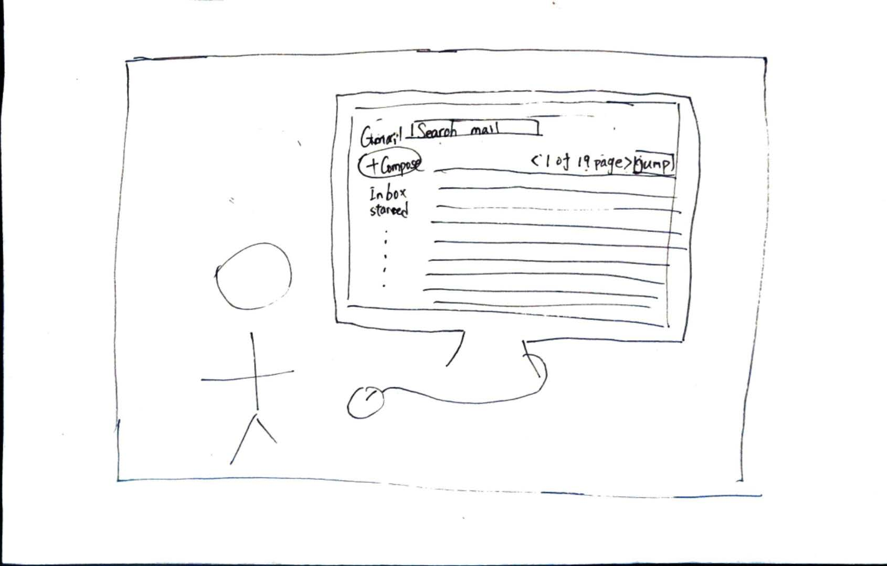

Zheng try to find his transfer degree email in April 2018 in his Gmail today, so he login in his Gmail.

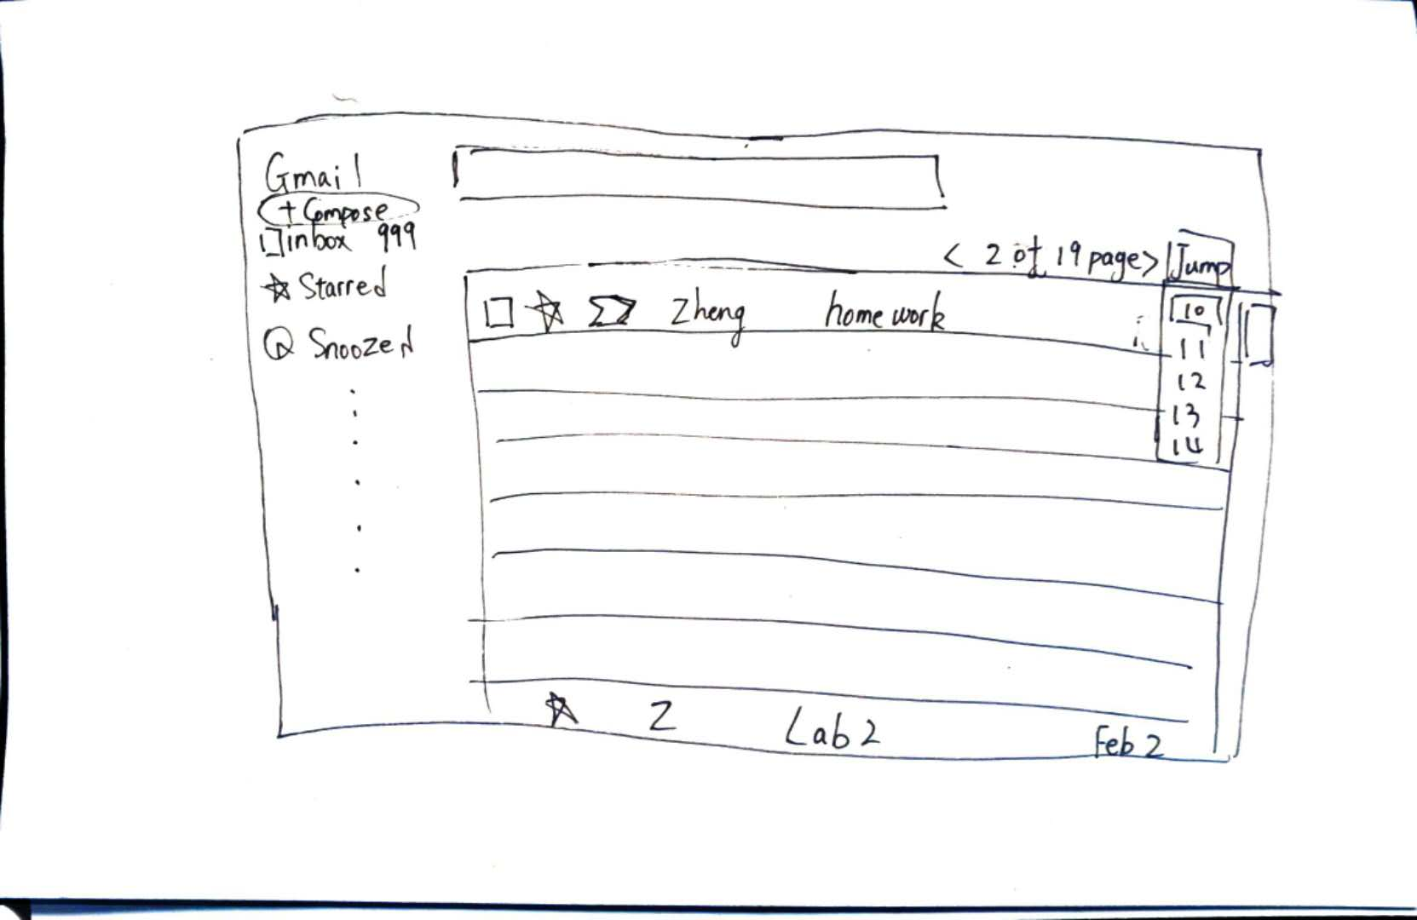

He uses next page button to check email one by one, but it is too slow. He thinks start with half of the total email will be quicker, so he jumps to page 10.

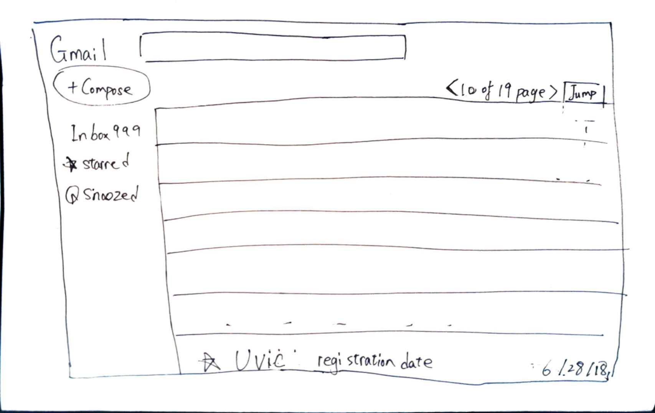

When he gets to page ten, and he sees the last mail is on June 28 2018, he thinks the mail he want is close.

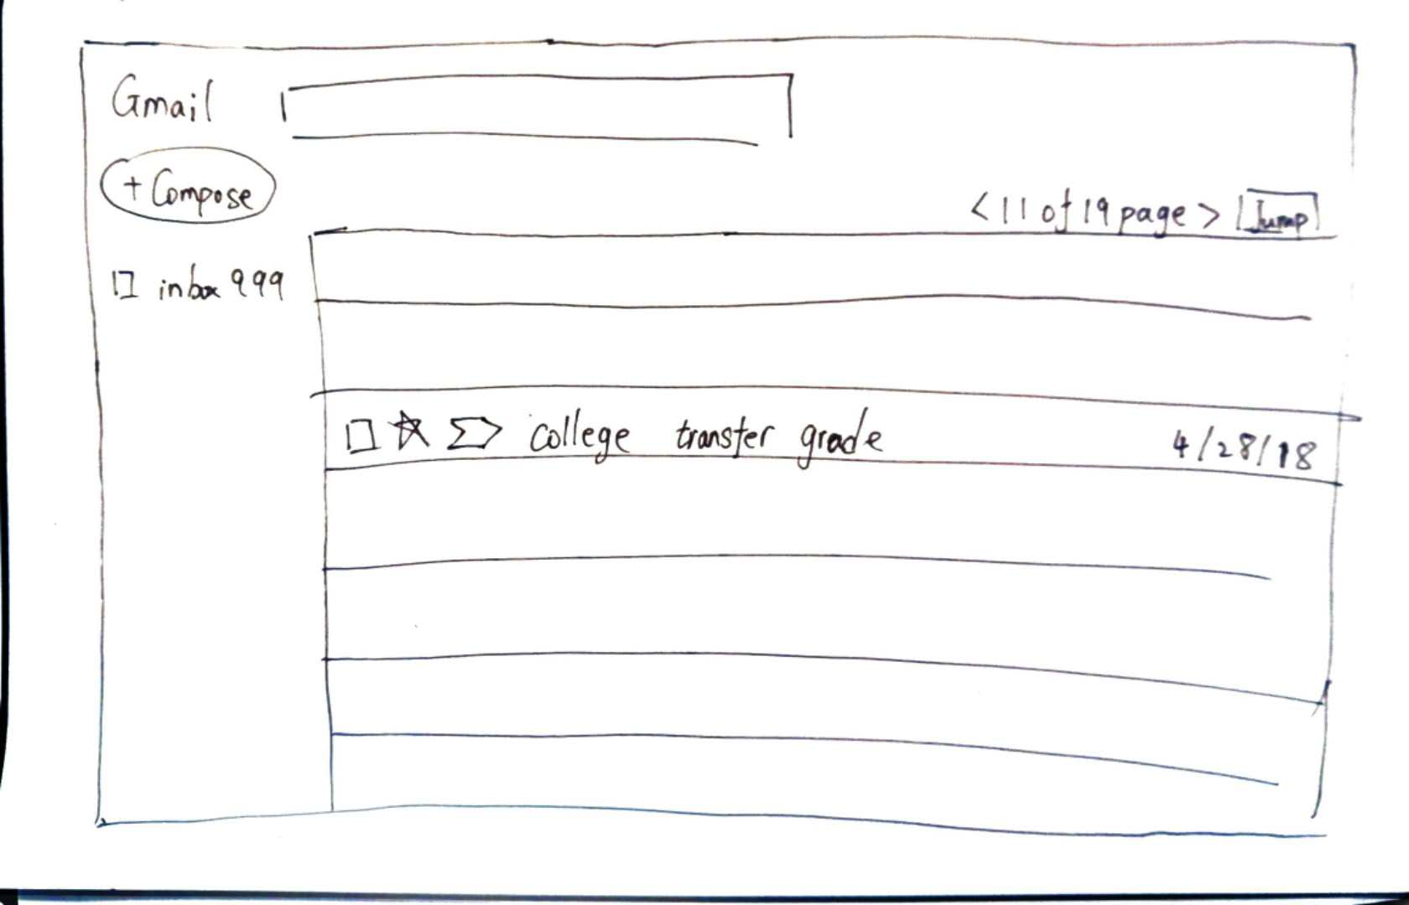

Turn to the next page, he finds the mail from his college about his transfer degree.

**Question 5:**

Assume that you are asked to re-design the sub-part of the interface using the human-centered design process.

(a) Create a persona for someone you would consider is a typical user for the interface and provide rationale for your choice. [5 marks]

(b) Develop one key task description for this persona and provide rationale for your choice. [5 marks]

(c) Lastly, demonstrate, using sketches and/or textual descriptions, **two different** solutions for how the persona can complete the identified task and describe the strengths and limitations of the different solutions. Again, the sketches must be included as figures and you must not provide link to an external site. [10 marks]

(a) We can consider a UVic student named John Yin, and he uses Gmail as his email address for UVic. He has 6 courses in this term, and he takes online course due to COVID-19. He is taking SENG 310.He is a very inquisitive student.

The reason why I set this persona is James must receive a lot of email from CourseSpaces or Connex, so it will be hard to find the specific email by the number of email growing.

(b)

John Yin, a computer science student in UVic, is a very inquisitive student that always send teachers for questions, taking SENG 310 right now. He uses his Gmail as the email address for UVic. There are lots of activity in SENG 310, so there are many automatic notifications in his email box. In the same time, John has many replies from teachers that answer his questions. Now he needs to find an email from TA that attach “TCSD guildline.pdf” which can help him to write task descriptions.

Discussion. Like John, a user of Gmail that never clean their email box, with a lot of emails. Now a modest number of students also use Gmail as the most important connection tool and suffered with a lot of emails. People always need to find the email they want from hundreds of emails.

Question C:

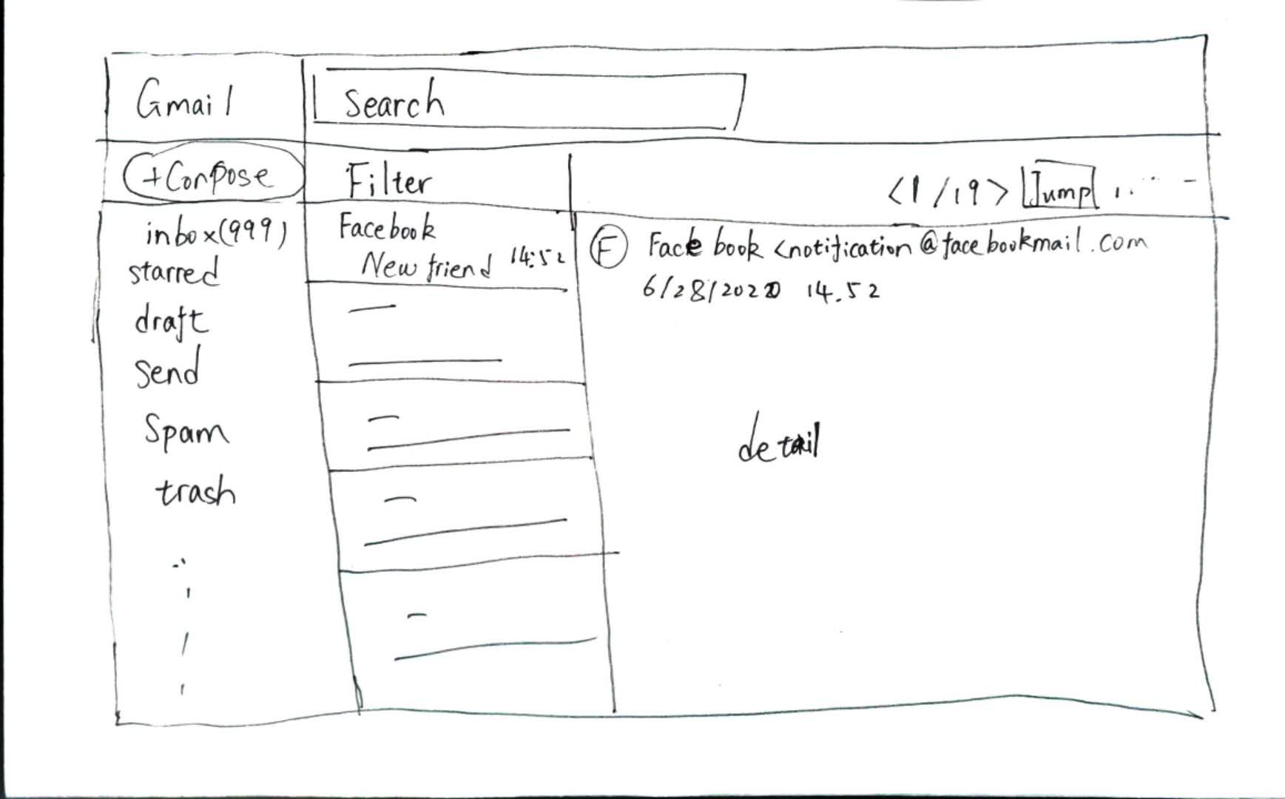

Main page of the re-design interface.

Solution 1: use TA’s name as key word to search the email.

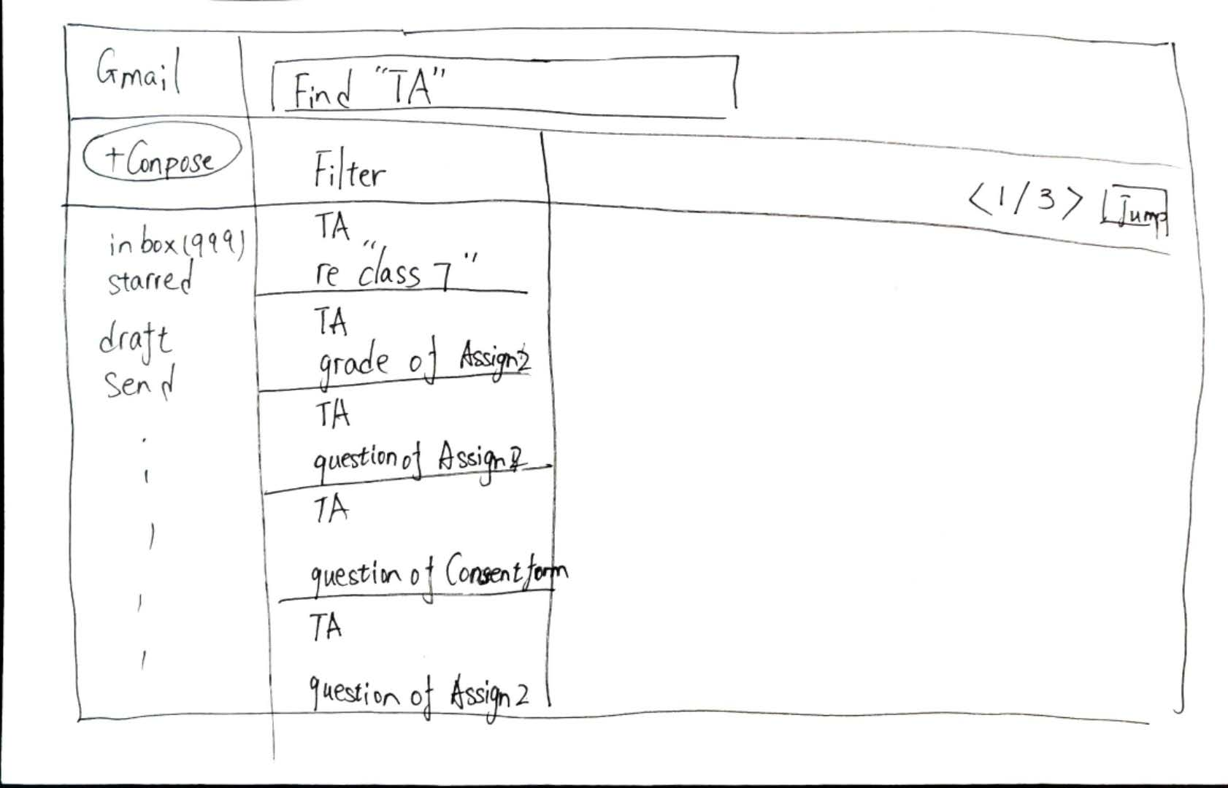

Use TA name on search.

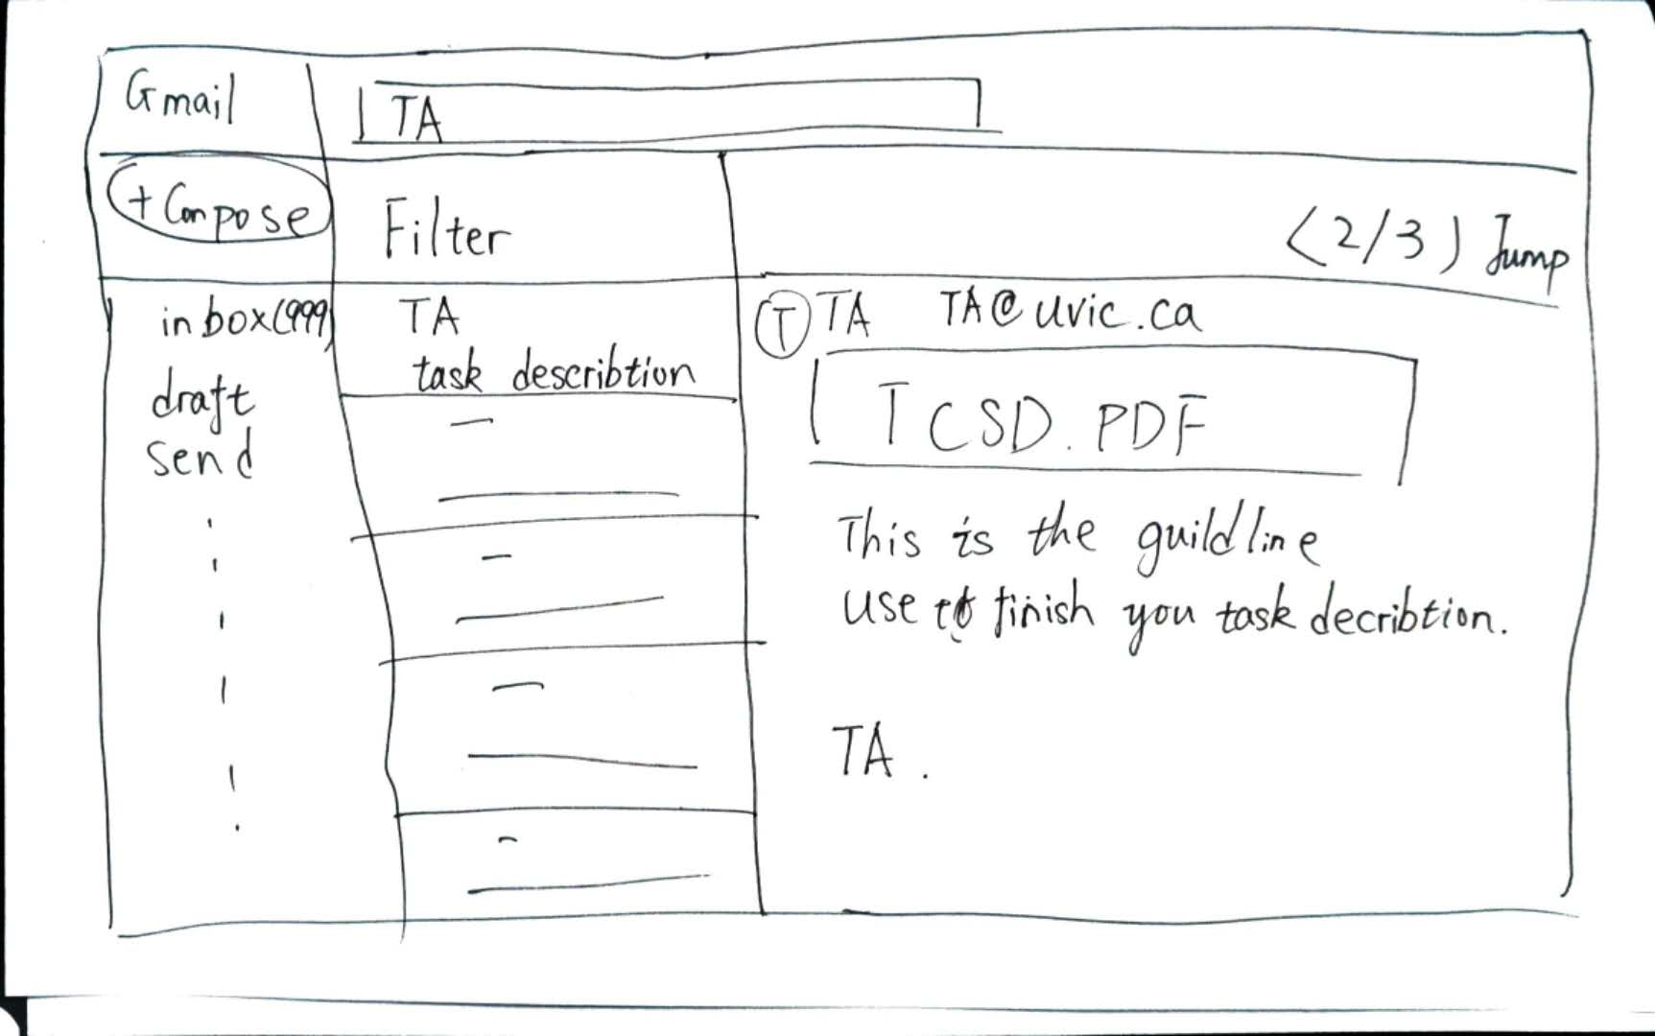

Turn other page find the email

Solution 2: use two date as filter to find all email in that time.

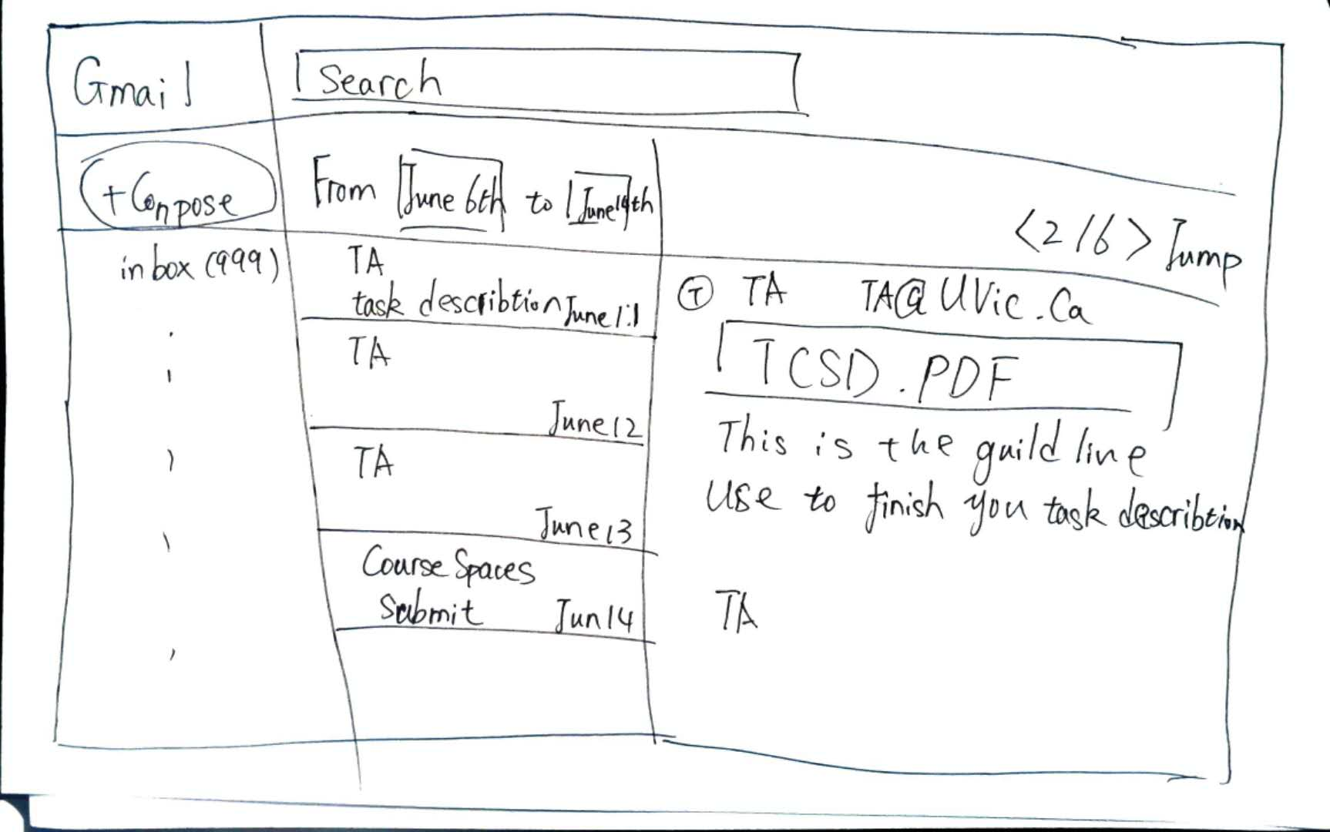

The strength of search by sender’s name is the emails come out will be less, so it means less email need to check to find the email that John wants. The limitation is all email from TA with Attach file need to be checked, and John need to remember TA’s name.

The strength of filter by time is only need a time or date, and there will be less email has attached file between two times. The limitation is there are more email will come out which there will be more page need to turn.